
Topic: Climagram II
Revision– Classification and parameters of the climatic zones and biomes
State the value and the changes in the average annual temperature during the year, annual precipitation, the frequency of the rainfall during the year, the differences between the northern and southern hemisphere, the differences between maritime and continental climate etc.
Climatic zones
Tropical -
Subtropical -
Temperate zone -
Sub polar zone -
Polar zone -
Biomes:
Tropical rainforest
Savanna -
Desert -
Prairie, steppe -
Temperate deciduous forest -
Temperate boreal forest, taiga -
Tundra -
Polar region
Work
Evaluate 4 climagrams:
Index | Climagram 1 | Climagram 2 | Climagram 3 | Climagram 4
Estimate average annual temperature
Describe the variations in average monthly temperature during the year
Calculate the total annual precipitation/the total rainfall for the year/
Does the snow cover occur on the specific place?
How frequent are the rainfalls during the year? ?
Estimate where the place lies/climatic zone, biome/
Is it on the southern or northern hemisphere?

Climagram 1
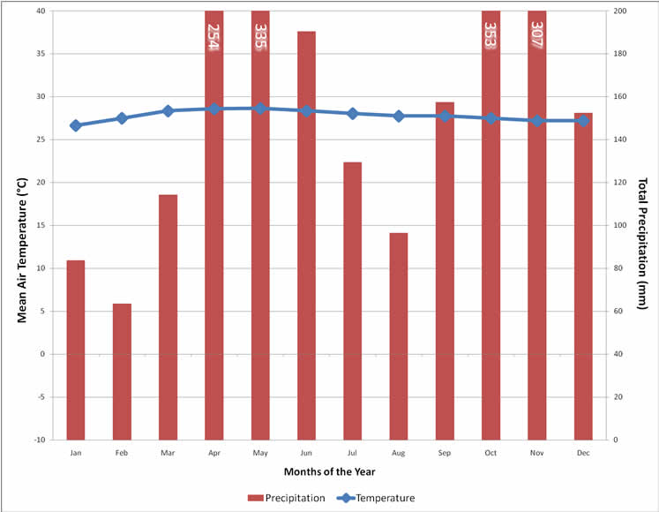
Climagram 2
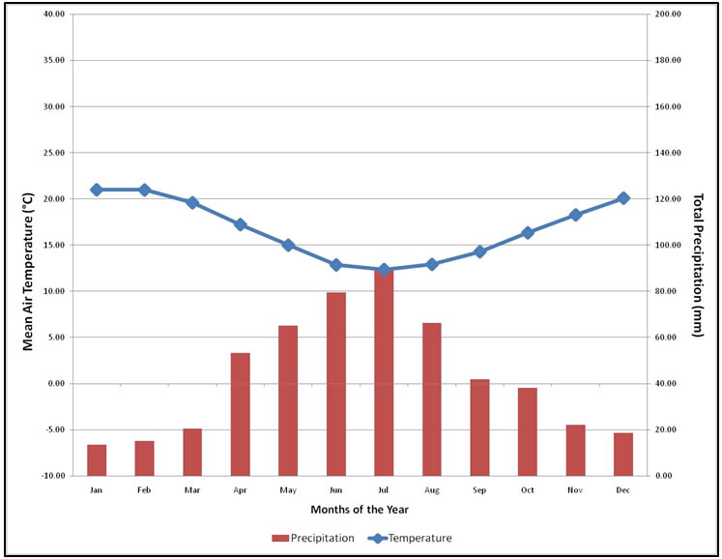

Climagram 3
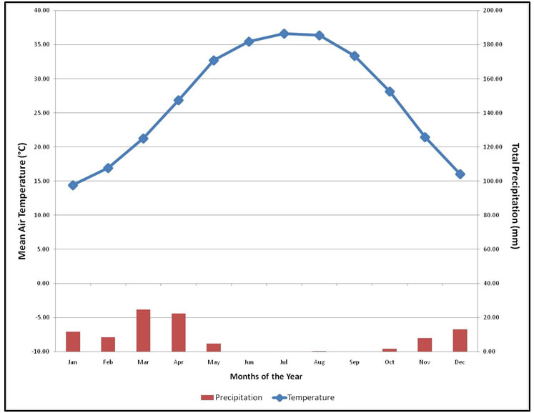

Climagram 4
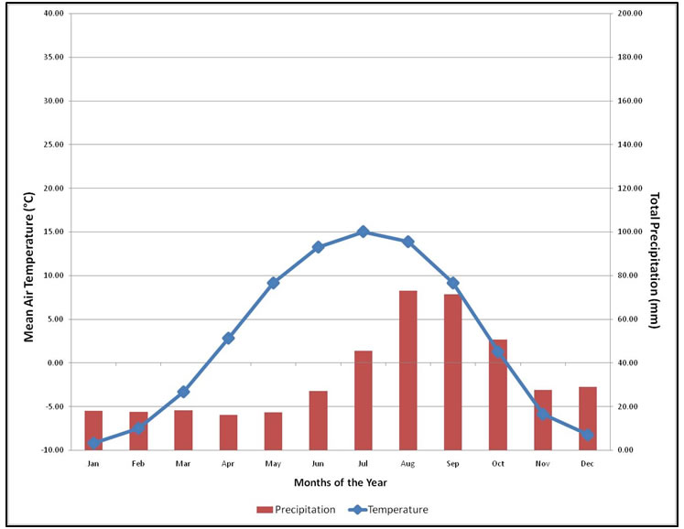

The project is financed by the grant support of the Education and Culture Lifelong learning programme Comenius. The editor is responsible for the article content and the European Commission is not responsible for any use of the mentioned information.

