
Topic: Climagram I – methodical manual for the teachers
Goal: students can evaluate climagrams and assign them to the accurate climatic zone/biomes/
Students age: 11-15 years
Time range: 1 lesson
Form of the work: individual or group work
Supposed knowledge and skills of the pupils /students/
- The term climatic zone and biome
- Classification and parameters of the climatic zones and biomes
Aids: teacher - a computer with a data projector, interactive whiteboard,
pupil – a computer, copied /coloured/worksheet
Part I. – revision
- students/pupils/ can record the data to the worksheet and then with the help of the teacher they can check the answers
- another possibility is a common discussion over the questions , the teacher leads the discussion and the pupils write the best answers in the worksheet

Part II. – the work with the climagram
- the pupils individually or in groups fill in the data to the table. The teacher can help if necessary
- the pupils estimate the climagram data , in the table with the solution there are the exact data , which can differ a bit

Index | Climagram 1 | Climagram 2 | Climagram 3 | Climagram 4
Estimate average annual temperature | 28ºC | 17ºC | 26ºC | 3ºC
Describe the variations in average monthly temperature during the year | High around  27ºC, almost unchanged | November - March the highest temperature to 21ºC, the lowest June –August 13ºC | Large differences, from 14ºC in winter to almost 37ºC in summer | Large differences form -10ºC in winter to 15ºC in summer
Calculate the total annual precipitation/the total rainfall for the year/ | cca 2200 mm/m² | cca 530 mm/m² | cca 100 mm/m² | cca 425 mm/m²
Does the snow cover occur on the specific place? | no | no | no | yes
How frequent are the rainfalls during the year? ? | April-May and October-November -rainy season | April –August more rainfall | It does not rain in summer in practice, in the other parts of the year rarely | Slight precipitation during the whole year, more in August and September
Estimate where the place lies/climatic zone, biome/ | Tropical rainforest | Subtropical/savanna | Subtropical/desert | Sub polar
Is it on the southern or northern hemisphere? | northern | southern | northern | northern

Climagram 1 – Colombo, Sri Lanka
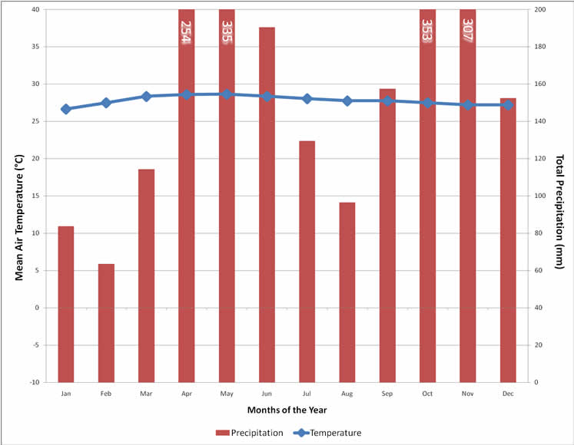
Climagram 2 – Cape Town, South Africa
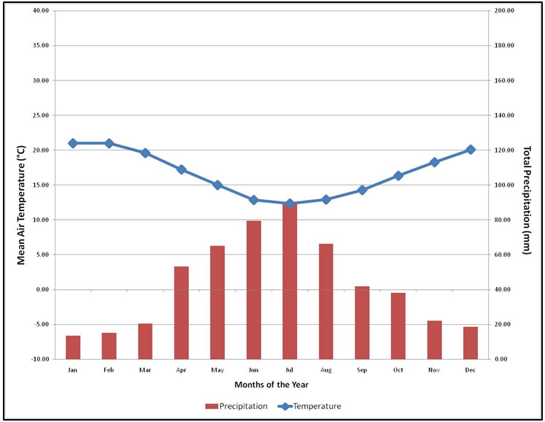

Climagram 3 – Riyadh, Saudi Arabia
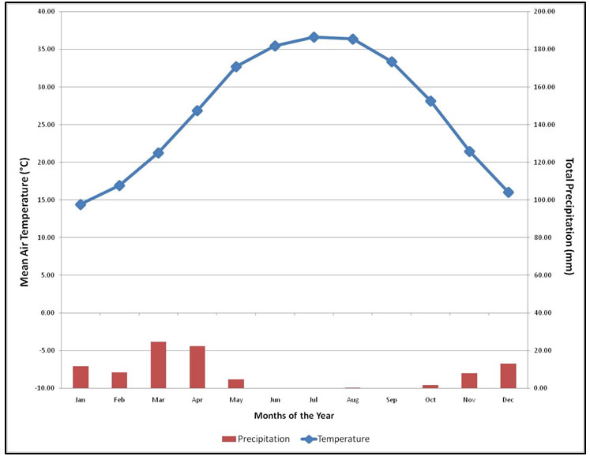

Climagram 4 – Anchorage, Alaska USA
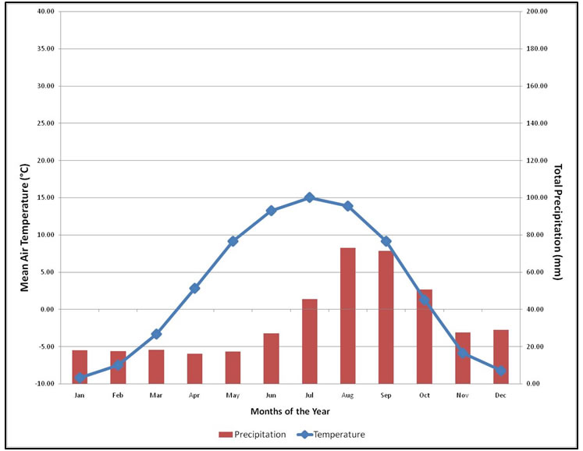

Part III. – checking the accuracy of the data
The teacher regulates the checking the answers, if they have an interactive whiteboard they show the correct answers hidden under the blind step by step

The project is financed by the grant support of the Education and Culture Lifelong learning programme Comenius. The editor is responsible for the article content and the European Commission is not responsible for any use of the mentioned information.

